BOARD OF INTERMEDIATE & SECONDARY EDUCATION SUKKUR-SINDH

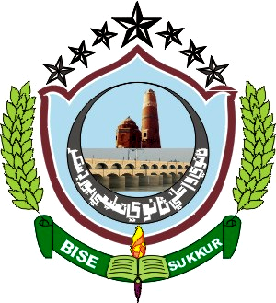
NO:BISE/HSC(S)/SUK/-2599 Dated: 07-11-2022

No

Position Holders
Website: www.bisesuksindh.edu.pk
Email: mail@bisesuksindh.edu.pk

NOTIFICATION

The Positions secured by the Candidates at the Higher Secondary Certificate Part-II (Class XII) Annual Examination 2022, (Commerce Group), held by the Board of Intermediate & Secondary Education, Sukkur, are declared provisionally, as under:-

- FIRST THREE CANDIDATES in order of Merit (BOYS)

Sr# | Seat  No: | Photograph | Name in Full (With Institution) | POSITION | MARKS  OBTAINED | Grade
1. | 132570 |  | Muhammad Atif  S/o  Muhammad Ashraf, Arain  Govt: Islamia Arts & commerce College, Sukkur | 1st | 935 | A-I
2. | 132601 |  | Vinod Kumar  S/o  Jayram  Govt: Islamia Arts & commerce College, Sukkur | 2nd | 912 | A-I
3. | 132596 |  | Sahil  S/o  Mahesh Kumar, Dhulani  Govt: Islamia Arts & commerce College, Sukkur | 3rd | 908 | A-I

- FIRST THREE CANDIDATES in order of Merit (GIRLS)

Sr# | Seat  No: | Photograph | Name in Full (With Institution) | POSITION | MARKS  OBTAINED | Grade
1. | 133222 | 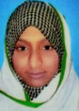 | Aina Afera  D/o  Muhammad Hassan, Abbasi  Govt: Girls Degree College,  Pir-Jo-Goth (Distt: Khairpur) | 1st | 910 | A-I
2. | 133227 | 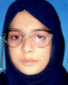 | Kalsoom  D/o  Sakha Muhammad, Indhar  Govt: Girls Degree College,  Pir-Jo-Goth (Distt: Khairpur) | 2nd | 893 | A-I
3. | 132664 |  | Bisma Daudpota  D/o  Rafique Ahmed, Daudpota  Govt: Girls Degree College, Sukkur | 3rd | 889 | A-I
Continued on Page # 2

Page # 2

- OVER ALL FIRST THREE POSITIONS (Boys & Girls) IN ORDER OF MERIT
Sr# | Seat  No: | Photograph | Name in Full (With Institution) | POSITION | MARKS  OBTAINED | Grade
1. | 132570 |  | Muhammad Atif  S/o  Muhammad Ashraf, Arain  Govt: Islamia Arts & commerce College, Sukkur | 1st | 935 | A-I
2. | 132601 |  | Vinod Kumar  S/o  Jayram  Govt: Islamia Arts & commerce College, Sukkur | 2nd | 912 | A-I
3. | 133222 |  | Aina Afera  D/o  Muhammad Hassan, Abbasi  Govt: Girls Degree College,  Pir-Jo-Goth (Distt: Khairpur) | 3rd | 910 | A-I

The Board reserves the right of rectifying the mistakes/errors and omissions in the Positions / Results at any time, on the basis of original record of the Board.

( Jalaluddin Liskani )  Assistant Controller of Examinations  ( SECRET ) | ( Rafique Ahmed Palh )  Controller of Examinations

